BOW THAYER ANNOUNCES "BOJO RISIN'" TOUR
TO UNVEIL HIS NEW MUSICAL INSTRUMENT THE "BOJOTAR"
​​
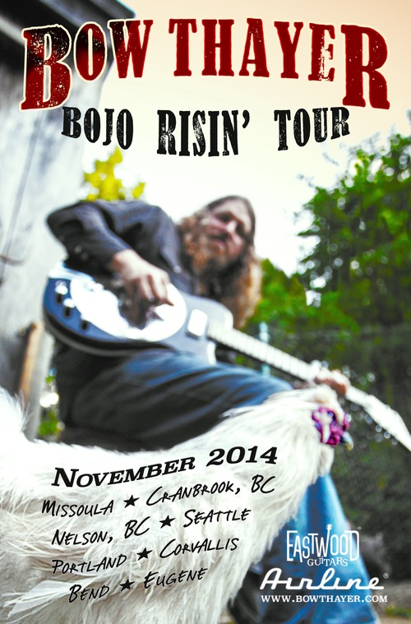

Vermont's Bow Thayer brings his Bojo Risin' Tour to the Northwest and Canada beginning on November 6, 2014.
The Bojo Risin' tour will introduce fans to new songs written on the "Bojotar," an instrument Bow developed with the Eastwood/Airline Guitar Company, available for sale in the near future.
Bow is an accomplished and prolific songwriter who cultivates influences from the worlds of rock, blues, folk, prog, bluegrass and everything and anything in between to produce music that is heartfelt, soulful and uniquely his. He has lived up to his “reputation as a sublimely gifted artist” by pursuing a creative vision that seeks to lead Americana music into the future. Finally gaining national recognition, American Songwriter Magazine says this "onetime Levon Helm compatriot is the best artist to come from New England in recent years."
The "Bojotar" is part resonator guitar, part electric guitar and part banjo and was invented by Bow because the instrument he needed to make the sound he wanted just didn't yet exist. Bow explains, "It had become more and more apparent to me that I was a frustrated guitar player trying to play banjo. Or a banjo player trying to play it more like a guitar. Either way, I like to play slide, I like to play banjo rolls, I like to finger pick, and flatpick, sometimes all in one song. I also love to experiment in alternate and open tunings. So by sheer necessity, I created this instrument, which makes this all possible. I think I may have found something here… and it appears the Eastwood Guitar Company is just crazy enough to agree."

Earlier this year, Bow released his first ever live album and he is currently working on his follow-up to his 2013 critically-acclaimed record, Eden. Click here for the EPK. The new record was written and performed on the "Bojotar" and he will premiere both the instrument and the music on this tour.

Tour dates (click here for details):

11/6 - Stage 112, Missoula, MT
11/7 - Stage Door, Cranbrook, BC
11/8 - Expressions Night Cafe, Nelson, BC
11/10 - Royal Room, Seattle, WA
11/11 - LaurelThirst Pub, Portland, OR
11/12 - Bombs Away Cafe, Corvallis, OR
11/13 - Volcanic Theatre Pub, Bend, OR
11/14 - Sam Bond's Garage, Eugene, OR
11/15 - The Lodge, Portland, OR

MORE ABOUT THE BOJOTAR:
The instrument has a chambered guitar body with a resonator, two pickups - a humbucker by the neck and a Piezo under the resonator's biscuit - and a three knob blending system that allows for many different varieties of tone.
Bow removed the low E string of a standard guitar by cutting the neck down to the fifth fret and replacing it with a drone string like a banjo, leaving it with an extra low note that a 5 string banjo does not have. This hybrid can be tuned to an open G, just like Keith Richards, or any other open tuning you want to explore. Bow plays it with a flat pick and two finger picks on his middle and ring finger, but the sky is the limit here. The Bojotar can be played with a banjo roll, strummed, or as a single note pick. Or with a blues finger style and a slide riff - all in one tune if you wish. Bow also plans on adding a B string bender to, as he puts it, "get into the world of some pseudo-pedal steel licks."

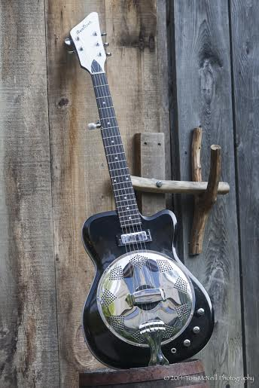

Website: http://bowthayer.com/
Facebook: https://www.facebook.com/bowthayermusic
MEDIA PLEASE CONTACT: Elizabeth Freund 718-522-5858 Elizabeth@BeautifulDayMedia.com

# # # #

