Sting & Paul Simon - On Stage Together
Launched 21-date tour in Texas last weekend

“It was an ‘experiment’ that succeeded by any measure on opening night…a seamless collaborative endeavor...adding richness and nuance to the song arrangements.” Gary Graff, Billboard Magazine.

“Sting and Simon are first-class musicians with equally high lyrical standards…I’ve never heard a more gorgeous rendition of Sting’s tune, ‘Fragile,’ thanks to his intricate guitar-picking and Simon’s wisdom-fueled singing.” Hunter Hauk, Dallas Morning News.

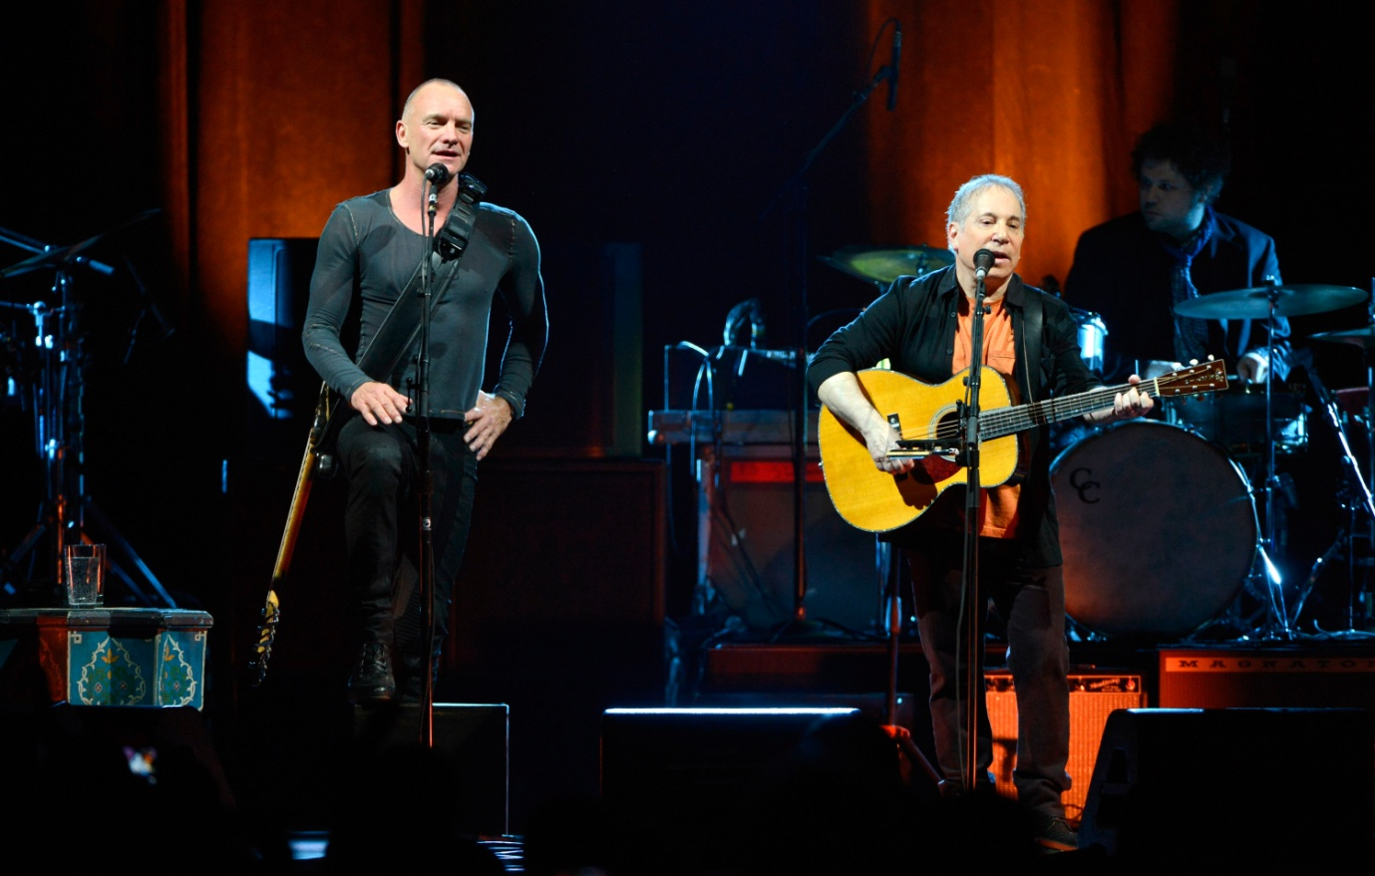
PHOTO CREDIT: KEVIN MAZUR - WIRE IMAGE:

CAPTION: Paul Simon & Sting kicked off their On Stage Together tour at the Toyota Center in Houston on Saturday February 8, 2014. For only 21 shows, two of music’s most iconic singer/songwriters blend their voices for many of their best-known songs, weaving through and exploring each others illustrious songbooks, performing together and individual sets with their respective bands.

Paul Simon & Sting - On Stage Together

New York, NY – Tuesday, February 11, 2014 – For Immediate Release. Sting & Paul Simon kicked off their “On Stage Together” tour this past weekend in Houston to both critical and fan acclaim.

The concert features two of music’s most iconic singer/songwriters blending their voices and their bands while performing their best-known songs both together and apart. With a set list of over 30 songs the audience was treated to some of the finest musicianship to appear on one stage.

The tour will continue for five weeks throughout North America with concerts in Los Angeles, Anaheim, San Jose, Seattle, Vancouver, St. Paul, Chicago, Detroit, Montreal, Toronto, Boston, New York, Philadelphia, Hershey and Ft. Lauderdale before a final stop in Orlando on March 16, 2014. Complete tour itinerary follows.

As long-time friends, the concept for “On Stage Together” originated when both artists shared the stage at the Robin Hood Foundation benefit last year. As Sting expressed in the interview footage attached, “there was an audible gasp” when they walked on stage together. And as Paul Simon noted, “...while we come from different places, by the time we performed together with a band it became a really interesting musical blend.”

When the tour was announced, Arthur Fogel, President-Global Touring and Chairman – Global Music Live Nation said the following: “We are thrilled to be bringing together these iconic artists. As individual artists, Paul and Sting have had a diverse and unique history, and I suspect the challenge for both of these prolific songwriters will indeed be narrowing down the song choices.”

The 30-plus song set features such favourites as “Boy In The Bubble,” “Fields of Gold,” “Driven To Tears,” “Mother & Child Reunion,” “Desert Rose,” “Every Breath You Take,” “The Boxer,” “Diamonds On The Soles of Her Shoes” and more.

Tickets for “Paul Simon & Sting: On Stage Together” are on sale now at www.ticketmaster.com. For additional tour and ticket information, please visit: www.simonandstingtour.com; www.livenation.com; www.sting.com; www.paulsimon.com
Media may view the “Sting & Paul Simon: On Stage Together” EPK by clicking on the link below.
http://lvn.at/PaulSimonSting

A higher resolution version may be downloaded here: http://we.tl/E2e4mxsYY2
Or please contact: Victor Trevino | VP Communications | North American Concerts
victortrevino@livenation.com | 310 867 7197 (office).
Please note, content is to be used for news purposes only in connection with the “On Stage Together” tour. Footage will be available only for the life of the tour. Additional usage thereafter with artist management permission only.

On Stage Together is produced by Live Nation Global Touring.

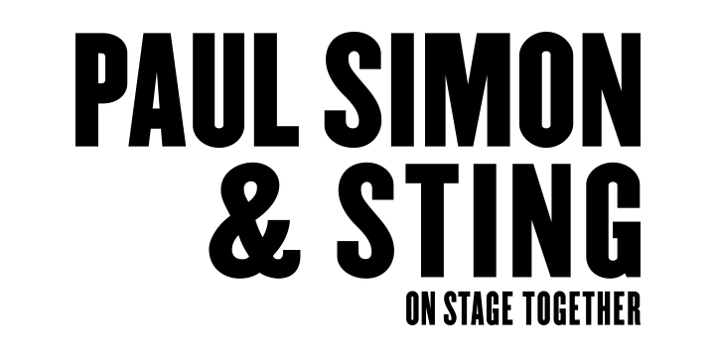
North American Tour Itinerary 2014
Feb. 08 Houston, TX Toyota Center
Feb. 09 Dallas, TX American Airlines Center
Feb. 11 Denver, CO Pepsi Center
Feb. 15 Los Angeles, CA Forum
Feb. 16 Anaheim, CA Honda Center
Feb. 17 San Jose, CA SAP Center at San Jose
Feb. 19 Seattle, WA KeyArena
Feb. 20 Vancouver, BC Rogers Arena
Feb. 23 St. Paul, MN Xcel Energy Center
Feb. 25 Chicago, IL United Center
Feb. 26 Detroit, MI The Palace of Auburn Hills
Feb. 28 Montreal, QC Bell Centre

Mar. 01 Toronto, ON Air Canada Centre
Mar. 03 Boston, MA TD Garden
Mar. 04 New York City, NY Madison Square Garden
Mar. 06 New York, City, NY Madison Square Garden
Mar. 07 Philadelphia, PA Wells Fargo Center
Mar. 09 Hershey, PA Giant Center
Mar. 13 Washington, DC Verizon Center
Mar. 15 Ft. Lauderdale, FL BB&T Center
Mar. 16 Orlando, FL Amway Center

For complete tour and artist information, visit: www.simonandstingtour.com; www.livenation.com; www.sting.com; www.paulsimon.com

For Live Nation, contact Jacqueline Peterson jacquelinepeterson@livenation.com

For Sting, contact Tracy Bufferd (tracy@tracybufferd.com) and Nicole VanGiesen (nicole@ksmgmt.com)

For Paul Simon, contact Elizabeth Freund (elizabeth@beautifuldaymedia.com)

About Live Nation Entertainment:
Live Nation Entertainment (NYSE: LYV) is the world’s leading live entertainment company comprised of four market leaders: Ticketmaster, Live Nation Concerts, Artist Nation Management and Live Nation Media/Sponsorship. For additional information, visit www.livenation.com/investors.

