BOW THAYER TO RELEASE NEW FULL LENGTH ALBUM,

SUNDOWSER
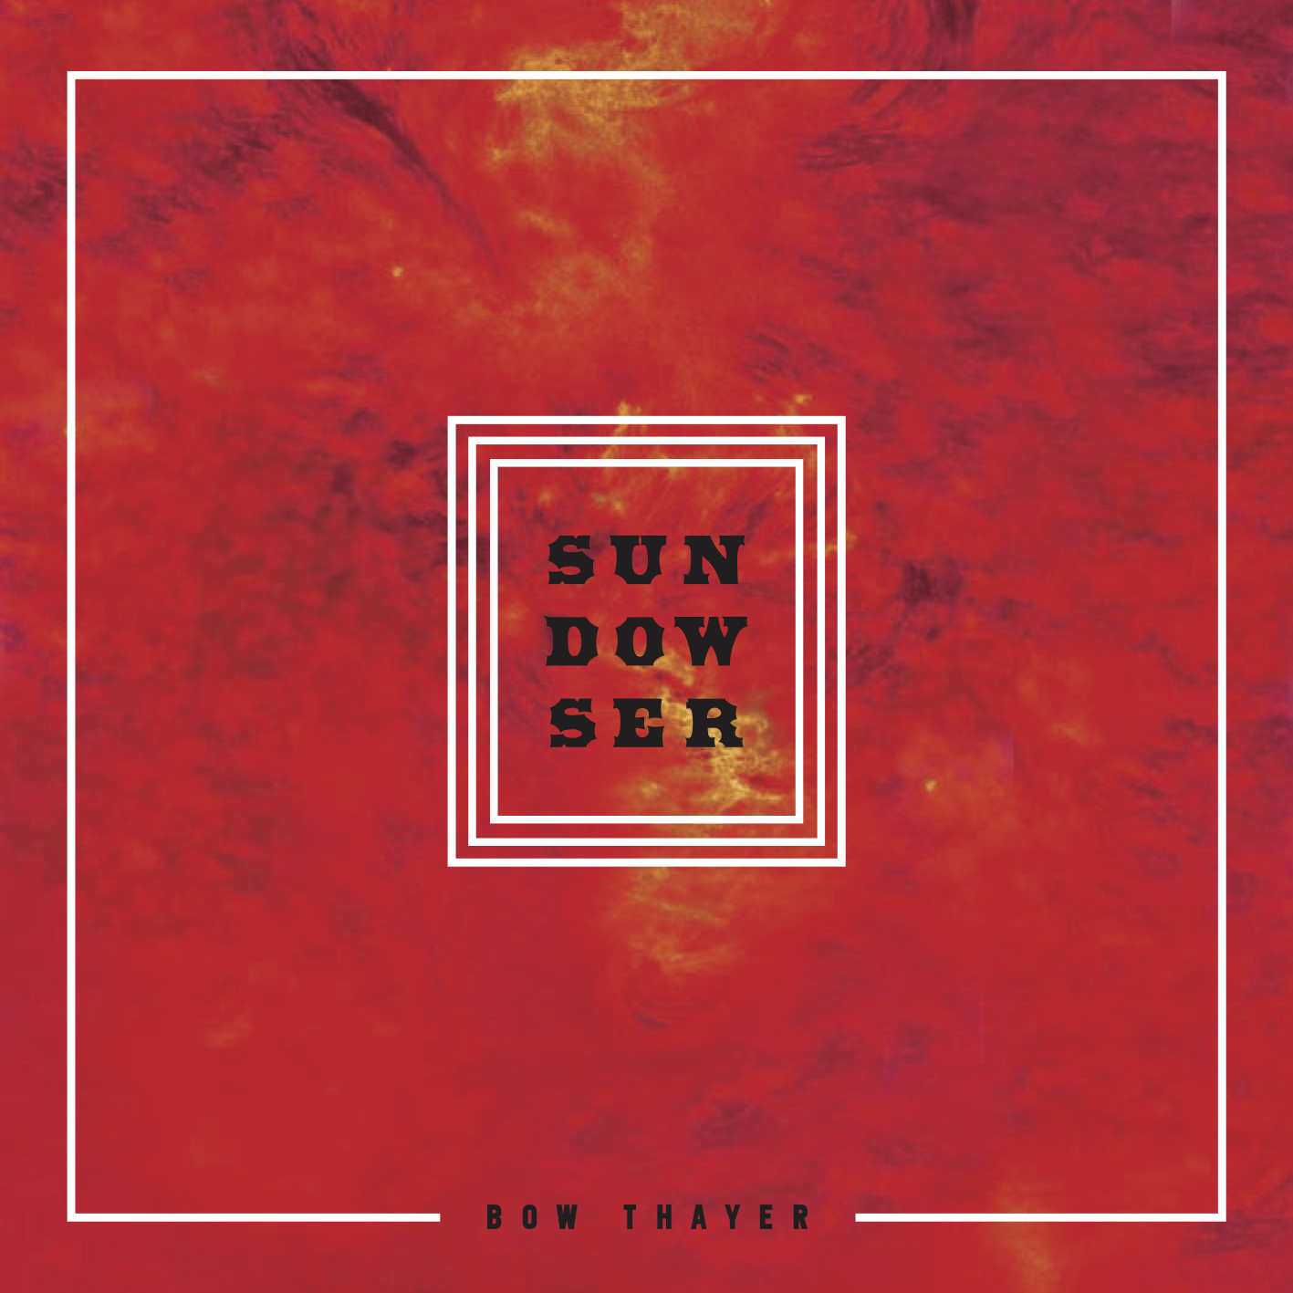

VIA PLEDGEMUSIC ON JULY, 24 2015

Album Features Debut Recording of the Bojotar, A New Instrument Invented by Bow with Eastwood/Airline Guitar Company

“The best artist to come from New England in recent years" – American Songwriter

"Thayer writes deep, heavily textured music with complex layers both sonically and lyrically and has the band and the chops to pull it all together." – The Alternate Root

“Bow Thayer is the epitome of the ‘songwriter’s songwriter.’” – Seven Days

Vermont musician Bow Thayer is releasing his new solo studio album, Sundowser, on July 24, 2015 with an exclusive pre-order campaign with PledgeMusic. Best known for his song, "Wingless Angels", from the album Spend It All that featured Levon Helm on drums, Bow has since embarked on a musical journey with Levon's engineer and three time Grammy Award winner Justin Guip. After exploring the 5 string electric banjo on 2013's critically acclaimed Eden, Thayer continues the theme of letting an instrument lead the way with Sundowser which features the recorded debut of the Bojotar, an instrument Bow invented and developed with Eastwood/Airline Guitar Company. The Bojotar is an amplified stringed instrument that incorporates elements of banjo, resonator guitar and electric guitar.

Bow was developing the Bojotar as he recorded Sundowser, so several different variations of the instrument make an appearance on the album. Sundowser was co- produced Justin Guip (Levon Helm) and features Jeff Berlin on Drums, Alex Abraham on Bass and JD Tolstoi on Keys as well as special guest performances by Marco Benevento and Tracy Bonham.

Sundowser comes out on the heels of last year’s LP, Eden, the swan song for Bow’s band Perfect Trainwreck. American Songwriter praised Eden, “In a different era, Bow Thayer and Perfect Trainwreck would have some well-deserved gold records on their walls.”

Bow Thayer’s music is always evolving - from luscious backwoods folk rock to the progressive adventurism of Eden, Bow returns to a more gritty earthy sound in Sundowser while still continuing on to some very atmospheric sonic exploration. Crafting the album on an instrument he created, in a studio he built with his own hands, these songs feel as personal and organic as the rural Vermont environs he wrote and recorded them in. The album has an underlying theme of the sun’s energy - you can hear it in the music as well as the lyrics. Each song has established a lush voice of its own, some are personal, some global, some both. But all of them inspired from the same blanket of light that can help us, or hurt us or again…. do both.

Continuing with the theme of sustainability and community, fans can pre-order Sundowser via PledgeMusic and Bow will donate a portion of the proceeds to the Vermont organization BALE (Build A Local Economy). He is also using the PledgeMusic platform as a way to draw attention to solar power, specifically RGS Energy, who made his home and studio 100% solar powered.

Fittingly the first video, “So We Build,” features footage of Thayer and friends constructing his studio affectionately called “The Woodshed”. This is a homegrown affair from start to finish and perhaps the best showcase yet for a man with multiple talents and driving vision.

Sundowser is available for pre-order exclusively through PledgeMusic, where Bow is also offering fans other unique exclusives and personalized items. Pre-ordering the album gives fans access to exclusive content in the weeks leading up to the official release date.

Track Listing:

1- Burning Miles
2- Dinner Warnings
3- So We Build
4- The Funeral Crasher
5- Horus
6- Tug of War
7- Downtrodder
8- Drug Lust
9- Lympus
10- Guild Talking
11- Borrow a Bus
12- Snow Goose

MORE ABOUT THE BOJOTAR:

The instrument has a chambered guitar body with a resonator, two pickups - a humbucker by the neck and a Piezo under the resonator's biscuit - and a three knob blending system that allows for many different varieties of tone.

Bow removed the low E string of a standard guitar by cutting the neck down to the fifth fret and replacing it with a drone string like a banjo, leaving it with an extra low note that a 5 string banjo does not have. This hybrid can be tuned to an open G, or any other open tuning you want to explore. Bow plays it with a flat pick and two finger picks on his middle and ring finger, but the sky is the limit here.

The Bojotar can be played with a banjo roll, strummed, frailed, flat picked, finger picked or used with a slide - all in one tune if you wish. Bow also plans on adding a B string bender to, as he puts it, "get into the world of some pseudo-pedal steel licks."
The Bojotar is currently in the Eastwood/Airline inventory and for sale on their website. A modification/upgrade will be available to set up the instrument exactly the way Thayer’s personal instrument is.

TWEED RIVER MUSIC FESTIVAL:

Bow will be hosting the 6th annual Tweed fest on the weekend of July 31st. It is a 3 day long music and arts festival he founded with fellow musicians, family and friends and will be held on Kenyon Fields along the Mad River near Waitsfield Vermont. It has the reputation for being the festival for folks who usually don’t like festivals, and is the embodiment of a vision to collectively express music, family and community for the greater good of everything!
Please visit www.tweedrivermusicfestival.com.

ABOUT BOW THAYER:

Bow is an accomplished and prolific songwriter who cultivates influences from the worlds of rock, blues, folk, prog, bluegrass and everything and anything in between to produce music that is heartfelt, soulful, and uniquely his. He has lived up to his “reputation as a sublimely gifted artist” by pursuing a creative vision that seeks to lead Americana music into the future. Gaining national recognition, American Songwriter Magazine says this "onetime Levon Helm compatriot is the best artist to come from New England in recent years."
Website: http://bowthayer.com/
Facebook: https://www.facebook.com/bowthayermusic

MEDIA PLEASE CONTACT: Elizabeth Freund
718-522-5858 Elizabeth@BeautifulDayMedia.com

