BOW THAYER ANNOUNCES FALL TOUR DATES SHOWCASING THE BOJOTAR

BOW and HIS SOLAR-POWERED SOUNDS WERE FEATURED IN SIERRA MAGAZINE

“His latest music video for his track ‘So We Build’ is a representation of Thayer himself: bold, creative, and slightly enigmatic in the best way.” - Elmore Magazine

"The creative vision is stunning and he will no doubt take Americana into new sonic territory" - Americana Music Show

"sonic majesty" - The Alternate Root

"Sundowser is another winner." - Pittsburgh In Tune

August 20, 2015 - Vermont musician Bow Thayer released his new solo studio album, Sundowser, on July 24, 2015 and celebrated with a performance earlier this month at Tweed River Music Festival, a festival he co-founded. With Sundowser, Bow returns to a more gritty, earthy sound while still continuing the atmospheric sonic exploration that is the hallmark of his recent work. Crafting the album on an instrument he created - the Bojotar - in a studio he built with his own hands, these songs feel as personal and organic as the rural Vermont environs he wrote and recorded them in.

Bow talks to Sierra Magazine about his interest in clean energy, the theme of the sun’s energy in his work and the solar-powered studio he built to record Sundowser. He explains the meaning of the word Sundowser, which he invented, with Sierra Magazine reporter Jules Zucker: “A dowser is a person who uses a stick or something similar to search for water,” said Bow. “Waterdowsing is a big thing in Vermont, so I made up my own version—sundowser, looking for light. It can refer to good old fashioned energy or be taken in a more spiritual, metaphorical sense.”

Sundowser includes the recording debut of the Bojotar, the instrument Bow developed with Eastwood/Airline Guitar Company. The Bojotar is an amplified stringed instrument that incorporates elements of banjo, resonator guitar and electric guitar, and he has been playing it on tour. While out on the road, Bow had the joy of introducing the Bojotar to fans and friends alike, including some of his musical peers and heroes, including Bela Fleck, Richard Thompson, The Steep Canyon Ramblers and Warren Haynes. Check out some of the photos below along with Bow’s captions.

Catch Bow & the Bojotar on tour this fall:
Bow Thayer Residency at Radio Bean, Burlington, VT
Fridays in September (September 4, 11, 18 & 25)

Bow Thayer & Kelly Ravin (Waylon Speed):
Oct 14 Lamp Chop - Burlington ,VT ( next to Radio Bean )
Oct 15 Brickhouse - Dover, NH
Oct 16 Strange Brew - New Haven, CT
Oct 17 The Perfect Wife - Manchester, VT
Oct 18 Atwoods Tavern - Cambridge, MA

Bow Thayer & Patrick Ross (with Alex Abraham):
Oct 24 Newbury, VT - Court St. Arts presents Mountain Money with Patrick Ross & Bow Thayer (with Alex Abraham)

Bow Thayer:
November 5 The Grey Eagle, Asheville, NC
November 21 Old Ship Coffee House, Hingham, MA
The Bojotar & Friends:
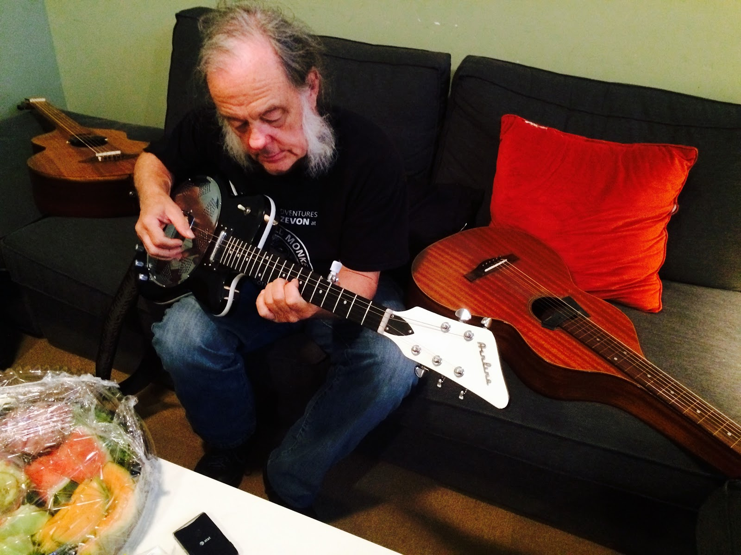

David Lindley can and does play anything. He is a “stringthusiast”. He loved the Airline Bojotar and half joked that it is the future for all them 5 string banjo folks. Then he gave me a quick Ude lesson in both The Arabic and Turkish tunings… Umm, I think I will just try and tackle open G on the” Bojo” for now. Oh and that is NOT a “cat food sandwich” on the table.

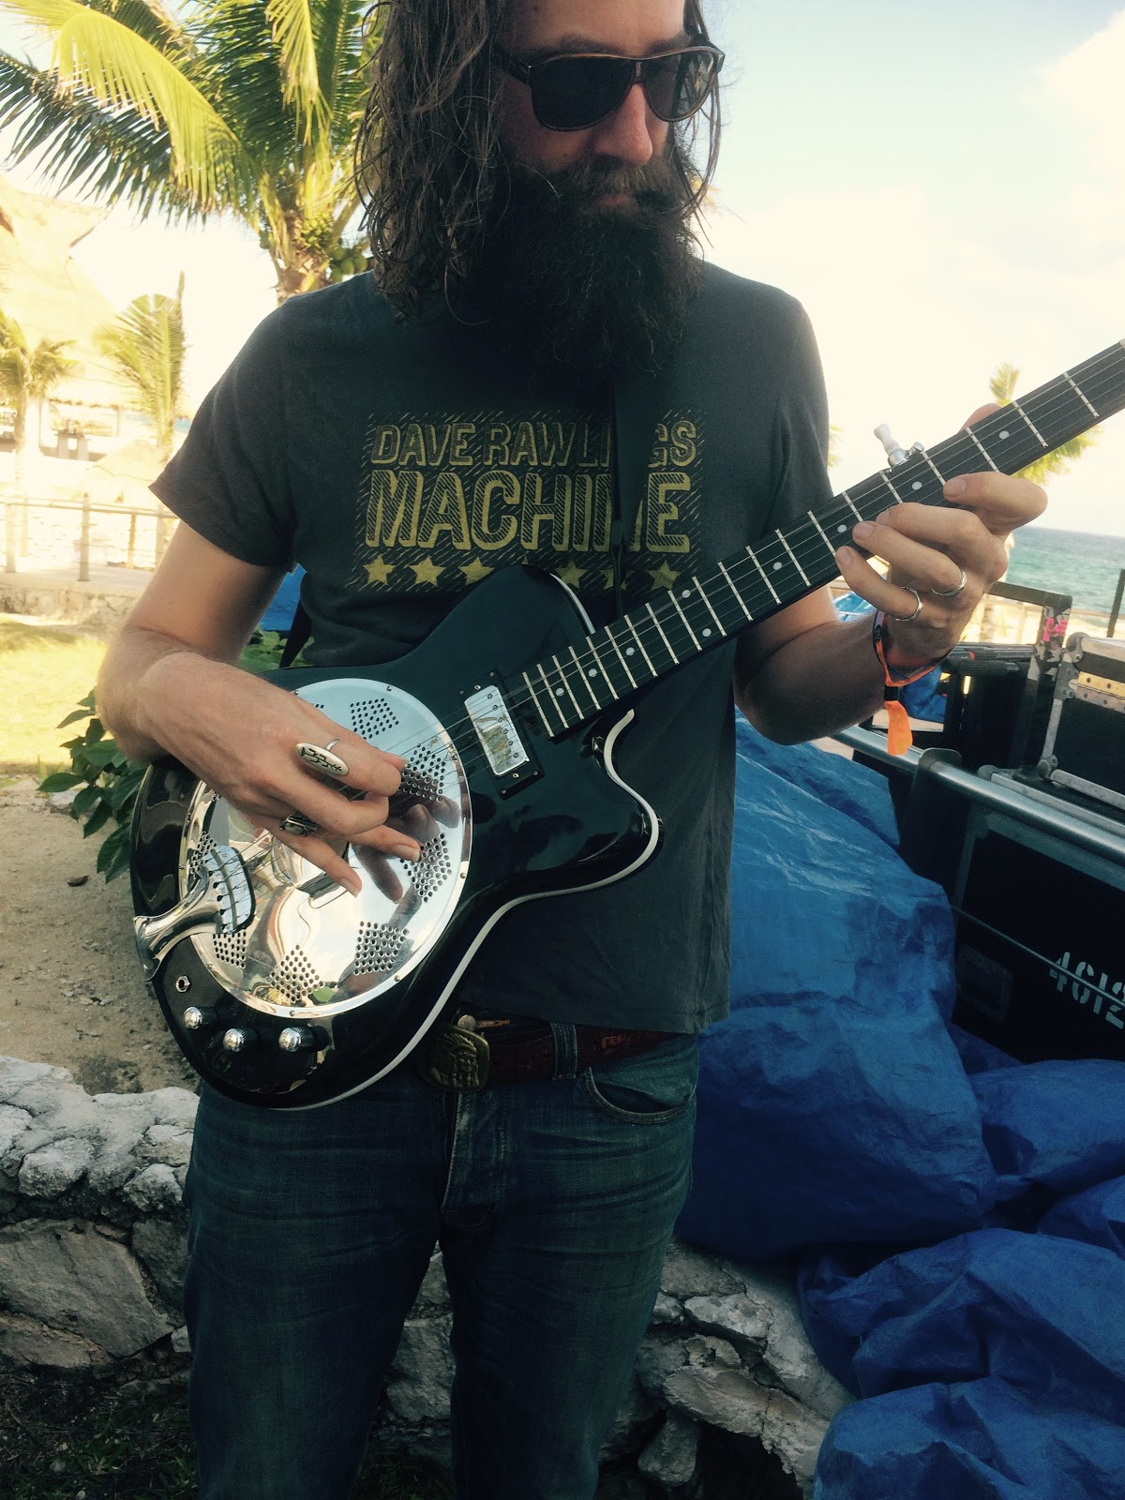

Tyler Ramsey ( Band of Horses) .
I met Tyler at a festival in Mexico. Physically he is enormous and his amicable personality is even larger. I was instantly put at ease in his presence even though I was interrupting his sound check. He picked up the Bojotar and played it like it was his first instrument… WTF! He then asked if he could use it in the Band of Horses set that evening, which he did, and he rocked it!

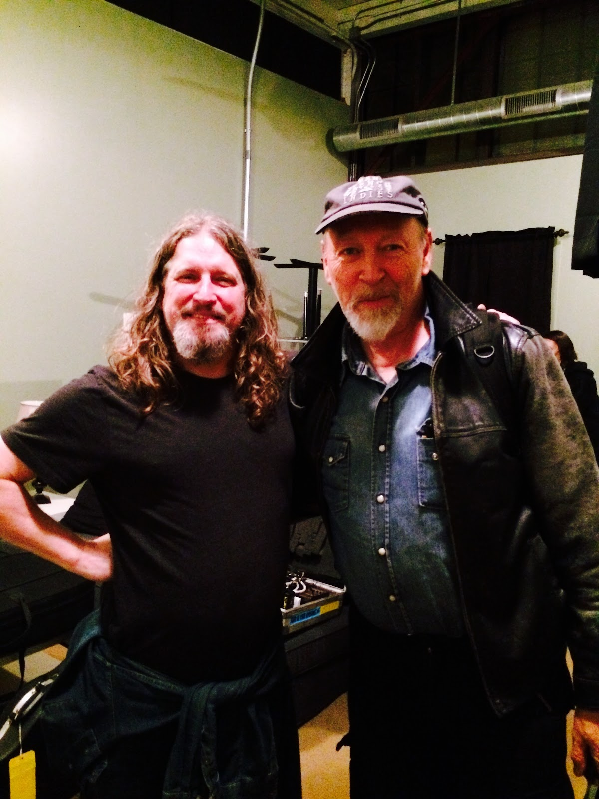

There is a reason Richard Thompson is on the Rolling Stone list of top 10 guitarists of all time. I was reminded why when I was fortunate to open a show for him. We discussed the benefits of using a flatpick and picking with the middle and ring finger, a method I am trying to use on the Bojo. I learned so much from him in the short amount of time in his presence… and not just about playing but about getting on in general.

.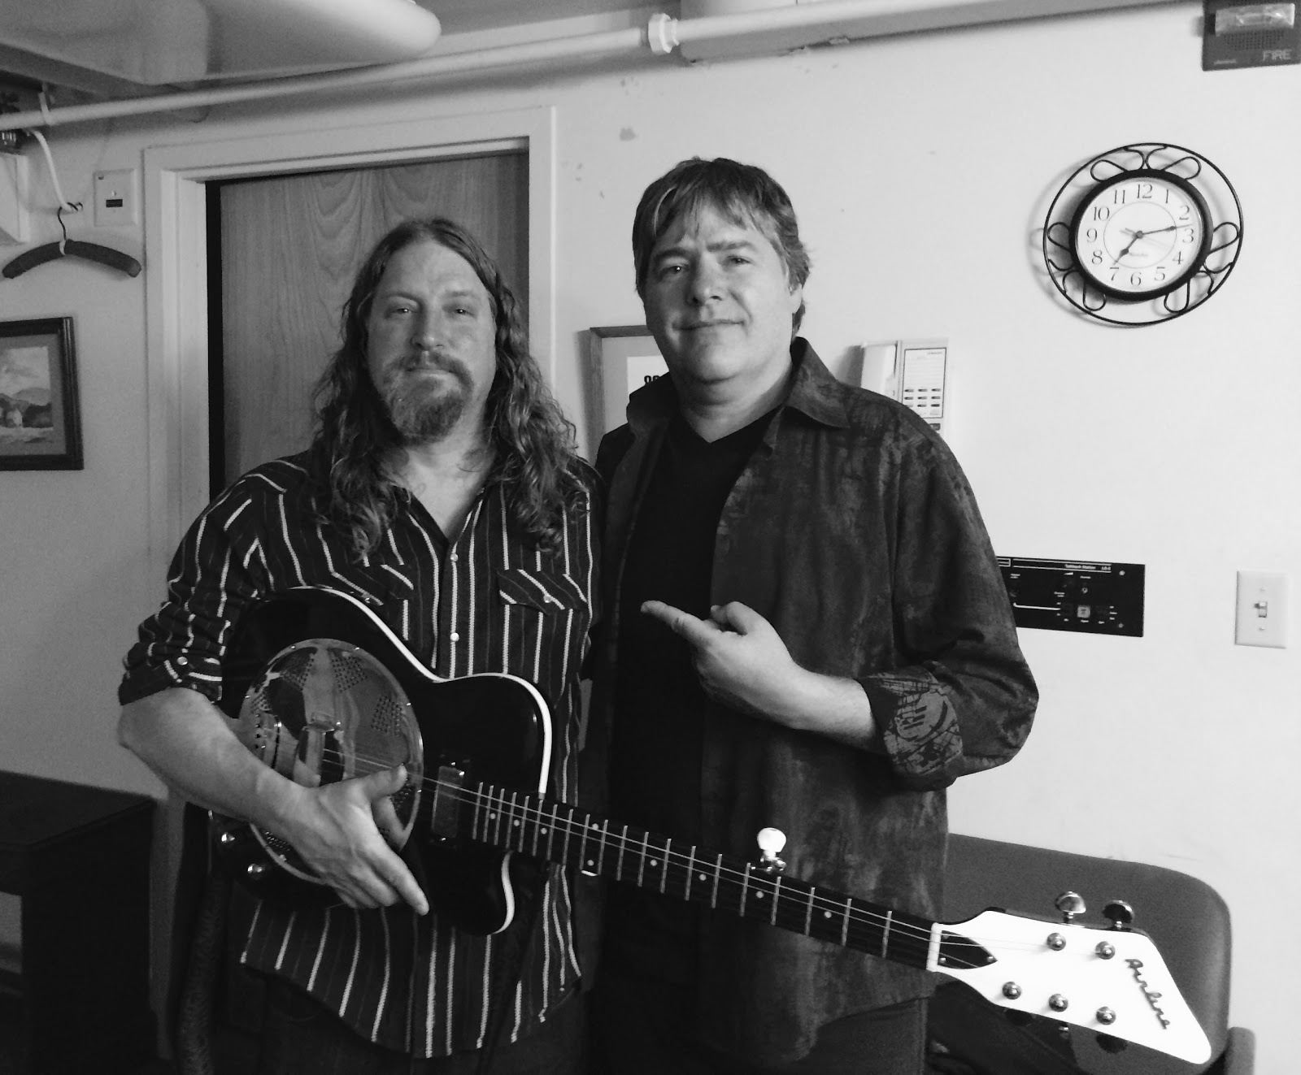

Bela Fleck
I was nervous as hell meeting the GOD of modern day banjo. Kinda like Wayne and Garth bowing in a chorus of “I am not worthy" and perhaps I am not, but Bela agreed to give me some time backstage and I've got to say he is a sweetheart of a guy. He picked up the Bojo, made a comment on how it was not set up very well and shredded it like only Bela could do. As he gave it back to me he said, ”This is really cool, but I would have no idea what to do with this thing, that extra low string would just trip me up.” Ya right I thought… but he gave me some invaluable advice. He said, "You know Bow, you can try and get all these famous players to try this thing but really great players already HAVE their thing… that is why they are great. It is up to YOU to play this instrument and make it sing. You get real good at this and people will want one, but it is up to you." Thanks Bela, I will be in the woodshed, see ya in a few years!

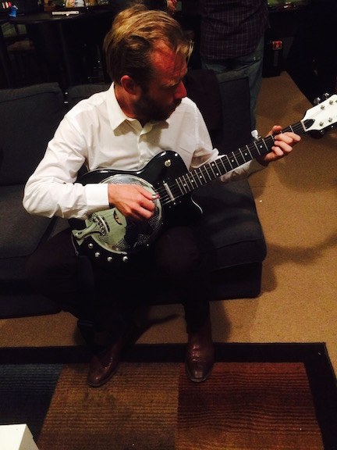

Graham Sharp ( steep Canyon Ramblers)
When I was mixing Sundowser with Justin Guip he played me the bluegrass group he was working with. We were listening to the basic tracks of the Steep Canyon Rangers latest effort and I was kicking my banjo under the couch in the event someone may make me pick it up in the wake of the 5 string assault coming through the monitors. I secretly hoped I would never have to go on after these cats... when I got the chance to open up for them however, I was all about it. Graham was magnetized to the stage during my check and very interested in the Bojotar. I can only imagine what would happen if he owned one of these things.
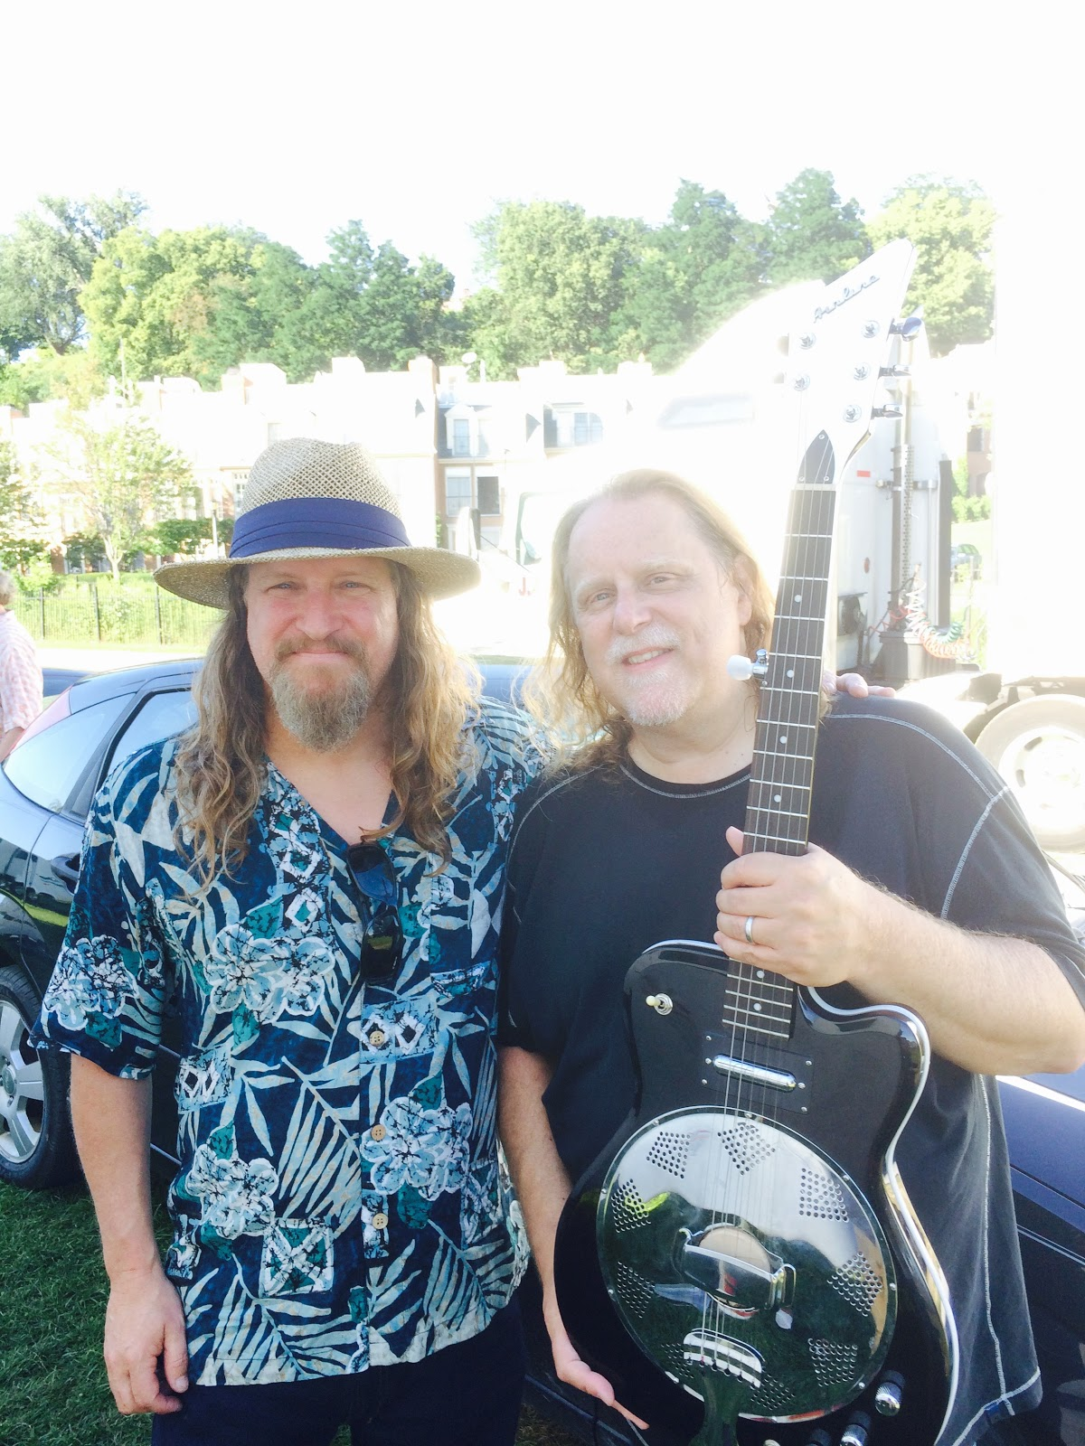

Warren Haynes
I met Warren at the very first Mountain Jam when it was in VT back in 1989 when I was with my old band Elbow. I had no idea that the next time our paths crossed I would be showing him an instrument of my own design. Warren is a gracious monster and he gets better and better with age. He seemed a bit skeptical at first, eyeballing that pesky 5th fret peg, but when I pulled out a slide I may have seen a bit of a light bulb flashed above his head.

